# CHAPTER 1 INTRODUCTION

* **AI-Driven Legal Support**: Lawyer.AI utilizes artificial intelligence, specifically Natural Language Processing and Deep Learning, to provide accessible and efficient legal assistance.
* **Real-Time Legal Advice**: The system offers real-time legal advice by analysing extensive legal data, enhancing decision-making processes and streamlining legal research.
* **Accessibility and Affordability**: The project addresses the need for affordable legal services, aiming to bridge the gap between complex legal systems and the general public.
* **Legal Education**: In addition to providing legal support, Lawyer.AI focuses on educating users about legalities, helping them feel more comfortable with India's legal system.

### Need of the system

* + - In this world of growing technologies everything has been computerized. With large numbers of law and orders for Human Lawyer.AI has been developed. Thus, there is a need of a system which can handle the data of such a large number of Laws in an organization.
    - Lawyer.AI helps the leman people (don’t know about law) to understand the Law.

### Detailed problem definition

* + - **Accessibility**: Many people find legal services expensive and difficult to access. Lawyer.AI aims to provide affordable legal support, making legal advice more accessible to the general public.
    - **Efficiency**: By leveraging AI, the system can process and analyze vast amounts of legal data quickly, providing real-time legal advice and streamlining legal research.
    - **Reliability**: AI algorithms can help reduce human error and provide consistent, reliable legal information.
    - **Education**: The project aims to educate the public about legal matters, making them more comfortable and informed about the legal system in India.
    - **Government scheme**: This AI aims to notify when the government launches a new scheme or program.

### Viability of the system

* + - **Guidance for Law**: Guidance in law refers to the principles, regulations, and recommendations that help individuals, lawyers, judges, and lawmakers interpret and apply legal rules.
    - **Self-sufficient**: refers to the ability of an individual or entity to provide for themselves without relying on public assistance, government aid, or external support.
    - **Educate law student**: it's important to provide a well-rounded curriculum that integrates legal theory, practical skills, and ethical training.
    - **Complete elimination of paperwork**: The complete elimination of paperwork refers to the shift from traditional paper-based processes to fully digital systems, where all documents, records, and transactions are handled electronically.

### Presently available system

* + - <https://www.lexisnexis.com/en-us/gateway.page>
    - It is not for normal people
    - It works on Business purpose
    - They only deal in professional domain.

### Future prospects

* + - Notify all new law implementation
    - Notify all government scheme
    - Make mobile application.
    - User can invite each other and form a community to deal with a particular problem.
    - This AI will suggest lawyer who has delt with similar cases in their career and provides information of Lawyer.

# CHAPTER-2 ANALYSIS

## Requirement Analysis

* + 1. **Authentication**
* **Login:** Customer would login the app then can login to the system with his/her username and password.
* **Logout:** the customer can log out from the system.
* **Login failure:** if the Customer does not exist in the database or the user has not yet been authorized by the admin of the system.
* **Update Profile:** Email, New-Password, Pin code
* **Sign up:** Email, Password, Pin code, Profession
  + 1. **Process data**
* **Display:** Finds the answer from the search history.
* **Search:** Users can search about anything related to legality.
* **Update authentication:** Any User can update their authentication.
* **Community search:** Lawyers can share and search their experience in blog.
* **Strategy Development:** This AI can help Law student to build their strategy.
* **Step by Step Guidance:** Will Guide you how to defend your case with important information of laws passed.

### Project Model

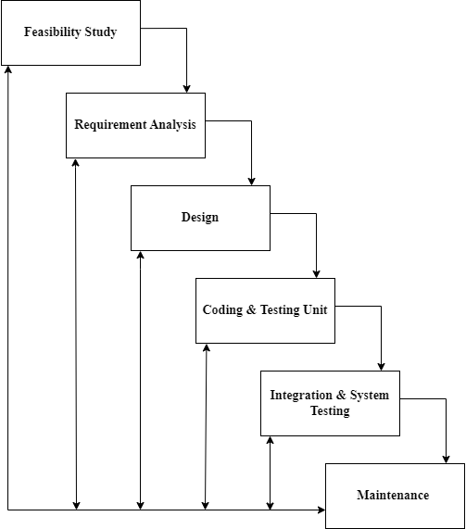

**[Figure 1: Iterative Waterfall Model]**

* This application is developed using Iterative model. Almost every other

model is derived from the waterfall model.

* The phase of detecting errors is close to its points of introduction is known as face containment of errors.
* Incremental model is also referred as the successive version of waterfall model using incremental approach and evolutionary model.
* In this model, the system has broken down into several modules which can be incrementally implemented and delivered.
* First develop the core model and when customer evaluate the system then the initial product skeleton is redefined into increasing levels capacity by adding new functionalities in successive versions.

### Advantages

* Each successive version performing more useful work than previous versions.
* The core modules get tested thoroughly, thereby reducing change of error in final product.
* The model is more flexible and less costly to change the scope and requirement.
* User gets a change to experiment with partially developed software.
* This model helps finishing exact user requirements.
* Feedback providing at each increment is useful for determining the better final product.

### Schedule Representation

Generalized project scheduling tools and technique can be applied with little modification to software projects.

Project evolution and review technique and critical paths method are two project scheduling method that can be applied to software development. Both techniques are driven by information already developed in earlier project planning activities:

* A decomposition of the product function.
* The selection of appropriate process model and task set.
* Estimate of effort.
* Decomposition of data.

**[Table 1: Schedule Representation]**

|  |  |  |
| --- | --- | --- |
| **ACTIVITY** | **START DATE** | **FINISH DATE** |
| Requirement Analysis |  |  |
| System Analysis |  |  |
| System Design |  |  |
| System Coding |  |  |
| Testing and Integration |  |  |

### Feasibility Study:

* + 1. **Technical Feasibility:**
       - The proposed system will be developed in web bases completely and it is required to use web technologies appropriately. Technology to build the overall system is available.
       - Currently available web technology – PHP, ASP.net
       - Front-End: HTML, CSS, React JS
       - Back-End: Python, Java, AI using Python
       - Servers – Apache
       - DBMS – MongoDB

### Economical Feasibility:

* + - * **Market Demand and Target Audience: Market Demand**:-

Assess the demand for affordable legal services. This includes understanding the size of the target audience, their legal needs, and their willingness to use an AI-based solution.

**Target Audience**: -

Identify the primary users, such as individuals seeking legal advice, small businesses, and legal professionals looking for research assistance.

* + - * **Cost Analysis**

**Development Costs**: -

This includes the cost of developing the AI algorithms, integrating Natural Language Processing (NLP) capabilities, and building the website or mobile app.

**Operational Costs**: -

Ongoing costs such as server maintenance, data storage, and regular updates to the AI system.

**Marketing Costs**: -

Expenses related to promoting the platform to attract users.

* + - * **Revenue Streams**

**Subscription Fees**: -

Charging users, a subscription fee for access to premium features or unlimited consultations.

**Pay-Per-Use**: -

Offering a pay-per-use model for specific legal queries or document reviews.

**Advertisements**: -

Generating revenue through advertisements from legal firms or related services.

**Partnerships**: -

Collaborating with law firms or legal institutions for mutual benefits.

### Operational Feasibility:

* + - * This AI based website aims to bridge the gap between Normal civilians who are deprived of the knowledge of constitution and law in this country.
      * This website will help people understand their rights and duties.
      * This website aims to be the one stop solution for everyone including Lawyers, Law Students and Normal Civilians.

**CHAPTER-3**

# DESIGN

### 3.1 Data Flow Diagram

* DFD (data flow diagram) is also known as bubble chart or data flow graph.
* DFD’s are very useful in understanding the system and can be effectively used during analysis. It shows flow of data through a system visually. The DFD is a hierarchical graphical model of a system the different processing activities or functions that the system performs and the data interchange among these functions.
* It views a system as a function that transforms the inputs into desired output.
* Each function is considered as a process that consumes some input data and produces some output data.
* Function model can be represented using DFD.
* DFD graphically representing the functions, or processes, which capture, manipulate, store, and distribute data between a system and its environment and between components of a system.
* The visual representation makes it a good communication tool between Userand System designer.
* Structure of DFD allows starting from a broad overview and expand it to a hierarchy of detailed diagrams.
* DFD has often been used due to the following reasons:
  1. Logical information flow of the system.
  2. Determination of physical system construction requirements.
  3. Simplicity of notation.
  4. Establishment of manual and automated systems requirements.

**[Table 2: Data Flow Diagram Symbols]**

|  |  |
| --- | --- |
| **Symbols** | **Description** |
|  | **Entity:** Entities are external to the system which interacts by inputting the data. |
|  | **System:** It shows the system name. |
|  | **Process:** It shows the part of the system that transforms into outputs. |
|  | **Data Flow:** It passes the data from one part to another. |
|  | **Data Store:** Data store is represented by two parallel lines. It is generally logical file or database. |

## Level 0 Context:

**[Figure 2: Context level]** 12

## Level 1: Admin

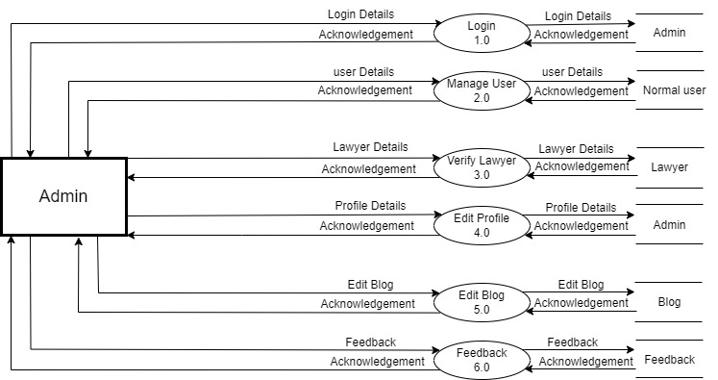

**[Figure 3: DFD Level 1: Admin]**

13

## Level 1: Normal user

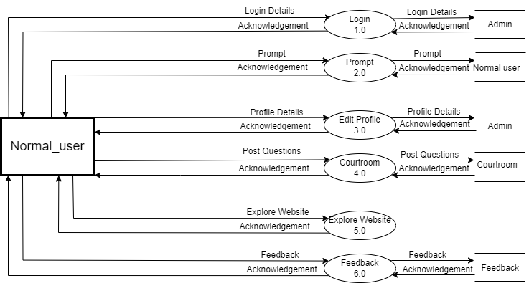

**[Figure 4: DFD Level 1: Normal User]**

14

## Level 1: LAWYER

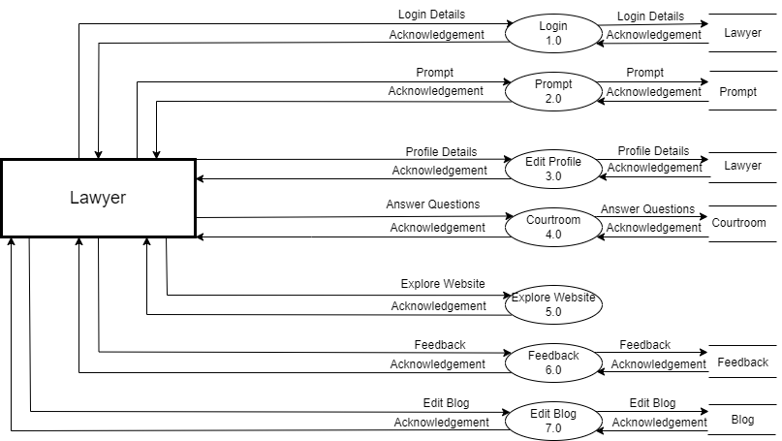

**[Figure 5: DFD Level 1: Lawyer]**

15

## Level 1: Law_Student

## 

**[Figure 6: DFD Level 1: Law Students]**

16

## 3.2 ER-Diagram

An Entity Relationship (ER) Diagram is a type of flowchart that illustrates how “entities” such as people, objects or concepts relate to each other within a system. ER Diagrams are most often used to design or debug relational databases in the fields of software engineering, business information systems, education and research. Also known as ERDs or ER Models, they use a defined set of symbols such as rectangles, diamonds, ovals and connecting lines to depict the interconnectedness of entities, relationships and their attributes. They mirror grammatical structure, with entities as nouns and relationships as verbs.

**[Table 3: ER-Diagram Symbols]**

|  |  |
| --- | --- |
| **Symbols** | **Description** |
|  | **Entity:** Data object is real world entity or thing. It is represented by a rectangle shape. An entity is an object or concept about which you  want to store information. |
|  | **Attributes:** An attribute is property of characteristic of an entity. It is represented by oval  shape. |
|  | **Relationship:** Entity are connected each other via relations. Generally, relationships in binary because there are two entities are related to  each other. |
|  | **Cardinality (One to One):** An  instance of entity A can relate to one instances of entity B. |
|  | **Cardinality (One to Many):** An instance of entity A can relate to one or many instances of B but we  can only relate one instance of A. |
|  | **Cardinality (Many to One):** One or more instances of entity A can relate to one instances of B. |
|  | **Cardinality (Many to Many):** One or more instances of entity A can relate to one more instance of  entity B. |

### ER – Diagram:

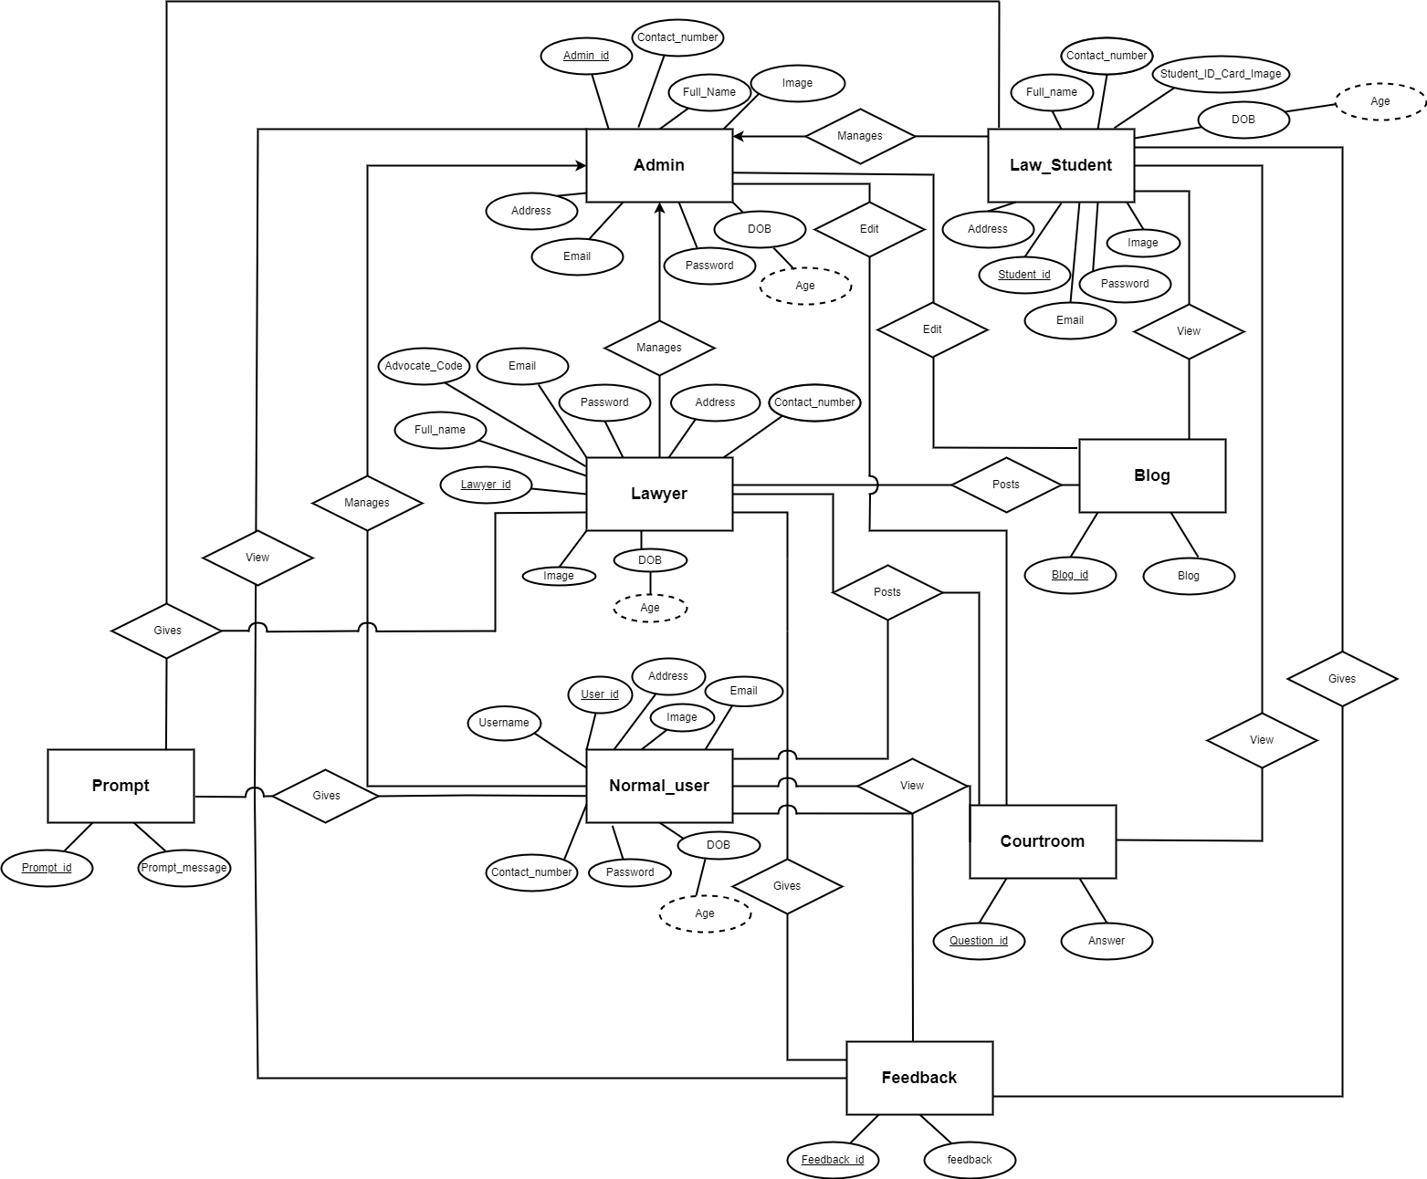

**[Figure 7:ER Diagram]** 19

**CHAPTER-4 SYSTEM MODELING**

### Database Dictionary

* + - 1. **Table Name:** Admin

**Primary Key:** Admin_id

**[Table 1: Admin]**

|  |  |  |  |  |
| --- | --- | --- | --- | --- |
| **SR.NO** | **FIELD NAME** | **DATATYPE(SIZE)** | **CONSTRAINT** | **DESCRIPTION** |
| 1 | Admin_id | Int (3) | Primary key | Admin’s id |
| 2 | Contact_number | Big_int (10) | Unique key | Contact number of  admin |
| 3 | Email | Varchar (30) | Unique key | Email of admin |
| 4 | Full_Name | Varchar (25) | Not null | Name of Admin |
| 5 | Password | Varchar (15) | Not null | Password of Admin |
| 6 | Address | Varchar (100) | Not null | Address of Admin |
| 7 | DOB | Int (10) | Not Null | Admin’s Date of  Birth |
| 8 | Image | Varchar (100) | Not Null | Admin’s Profile Picture |

* + - 1. **Table Name:** Normal_user

**Primary Key:** User_id

**Foreign Key:** Feedback_id, Question_id, Prompt_id

**[Table 2: Normal user]**

|  |  |  |  |  |
| --- | --- | --- | --- | --- |
| **SR.NO** | **FIELD NAME** | **DATATYPE(SIZE)** | **CONSTRAINT** | **DESCRIPTION** |
| 1 | User_id | Int (3) | Primary key | Id of user |
| 2 | Prompt_id | Int (3) | Foreign key | prompt’s id |
| 3 | Question_id | Int (3) | Foreign key | courtroom’s id |
| 4 | Feedback_id | Int (15) | Foreign key | Feedback’s id |
| 5 | Username | Varchar (10) | Unique key | User’s name |
| 6 | Contact_number | Big int (10) | Unique key | User’s contact number |
| 7 | Email | Varchar (30) | Unique key | User’s email |
| 8 | Password | Varchar (10) | Not null | User’s password |
| 9 | Address | Varchar (100) | Not null | User’s address |
| 10 | DOB | Int (10) | Not Null | User’s Date of Birth |
| 11 | Image | Varchar (100) | Not Null | User’s Profile Picture |

* + - 1. **Table Name:** Lawyer

**Primary Key:** Lawyer_id

**Foreign Key:** Blog_id, Question_id, Prompt_id, Feedback_id

**[Table 3: Lawyer]**

|  |  |  |  |  |
| --- | --- | --- | --- | --- |
| **SR.NO** | **FIELD NAME** | **DATATYPE(SIZE)** | **CONSTRAINT** | **DESCRIPTION** |
| 1 | Lawyer_id | Int (5) | Primary key | Id of lawyer |
| 2 | Blog_id | Int (23) | Foreign key | Blog’s id |
| 3 | Feedback_id | Varchar (15) | Foreign key | Feedback’s id |
| 4 | Question_id | Int (25) | Foreign key | Question’s id |
| 5 | Prompt_id | Int (20) | Foreign key | Prompt’s id |
| 6 | Contact_number | Big int (10) | Unique key | Lawyer’s contact no |
| 7 | Email | Varchar (30) | Unique key | Lawyer’s email |
| 8 | Full_name | Varchar (10) | Unique key | Lawyer’s user name |
| 9 | Password | Varchar (10) | Not null | Lawyer’s password |
| 10 | Address | Varchar (100) | Not null | Lawyer’s address |
| 11 | DOB | Varchar (10) | Not Null | Lawyer’s Date of Birth |
| 12 | Image | Varchar (100) | Not Null | Lawyer’s Profile Picture |
| 13 | Advocate_Code | Varchar (30) | Not Null | Verification code of lawyer |

* + - 1. **Table Name:** Law_Student

**Primary Key:** Student_id

**Foreign Key:** Prompt_id, Feedback_id

**[Table 4: Law student]**

|  |  |  |  |  |
| --- | --- | --- | --- | --- |
| **SR.NO** | **FIELD NAME** | **DATATYPE(SIZE)** | **CONSTRAINT** | **DESCRIPTION** |
| 1 | Student_id | Int (5) | Primary key | Id of law student |
| 2 | Prompt_id | Int (25) | Foreign key | Prompt’s id |
| 3 | Feedback_id | Varchar (15) | Foreign key | Feedback’s id |
| 4 | Full_name | Varchar (10) | Unique key | Student’s full name |
| 5 | Contact_number | Big int (10) | Unique key | Student’s contact no |
| 6 | Email | Varchar (30) | Unique key | Student’s email |
| 7 | Password | Varchar (10) | Not null | Student’s password |
| 8 | Address | Varchar (100) | Not null | Student’s address |
| 9 | DOB | Int (10) | Not Null | Student’s Date of Birth |
| 10 | Image | Varchar (100) | Not Null | Students Profile Photo |
| 11 | Student_ID_Card_  Image | Varchar (100) | Not Null | Students ID Card |

* + - 1. **Table Name:** Feedback

**Primary Key:** Feedback_id

**[Table 5: Feedback]**

|  |  |  |  |  |
| --- | --- | --- | --- | --- |
| **SR.NO** | **FIELD NAME** | **DATATYPE(SIZE)** | **CONSTRAINT** | **DESCRIPTION** |
| 1 | Feedback_id | Int (15) | Primary key | Feedback’s id |
| 2 | feedback | Varchar (500) | Not null | Feedback’s message |

* + - 1. **Table Name:** Blog

**Primary Key:** Blog_id

**[Table 6: Blog]**

|  |  |  |  |  |
| --- | --- | --- | --- | --- |
| **SR.NO** | **FIELD NAME** | **DATATYPE(SIZE)** | **CONSTRAINT** | **DESCRIPTION** |
| 1 | Blog_id | Int (3) | Primary key | blog’s id |
| 2 | Blog | Varchar (500) | Not null | blog’s message |

* + - 1. **Table Name:** Prompt

**Primary Key:** Prompt_id

**[Table 7: Prompt]**

|  |  |  |  |  |
| --- | --- | --- | --- | --- |
| **SR.NO** | **FIELD NAME** | **DATATYPE(SIZE)** | **CONSTRAINT** | **DESCRIPTION** |
| 1 | Prompt_id | Int (3) | Primary key | prompt’s id |
| 2 | Prompt_ message | Varchar (500) | Not null | prompt’s message |

* + - 1. **Table Name:** Courtroom

**Primary Key:** Question_id

**[Table 8: Courtroom]**

|  |  |  |  |  |
| --- | --- | --- | --- | --- |
| **SR.NO** | **FIELD NAME** | **DATATYPE(SIZE)** | **CONSTRAINT** | **DESCRIPTION** |
| 1 | Question_id | Int (3) | Primary key | courtroom’s id |
| 2 | Answer | Varchar (500) | Not null | courtroom’s message |

# CHAPTER-5 TECHNICAL SPECIFICATION

## Hardware Specification:

**5.1.1 Ram:** 4GB

**5.1.2 Hard drive Storage Needed:** 200GB

**5.1.3 Other Hardware Requirements:** None

## Platform:

**5.2.1 Supported Operating System:** Windows XP and above LINUX and MacOS is compatible.

**5.2.2 Programmer Server:** Apache Server 2.2.

## Framework:

**5.3.1 Mark-up Language:** HTML4 and HTML5.

**5.3.2 Programming Language:** PHP 5.3

## Technical Specification:

**5.4.1 Front-End:** React JS

**5.4.2 Back-End:** MongoDB

**5.4.3 IDE Tools:** Sublime Text3 and Visual Studio Code

**5.4.4 UML Tools:** Microsoft Office Visio 2007

**5.4.5 SRS Tools:** Microsoft Word 2016.

# DESIGN LAYOUT

## Homepage: -

**[Figure 8: Homepage]**

# USER: -

**[Figure: Sign up page]**

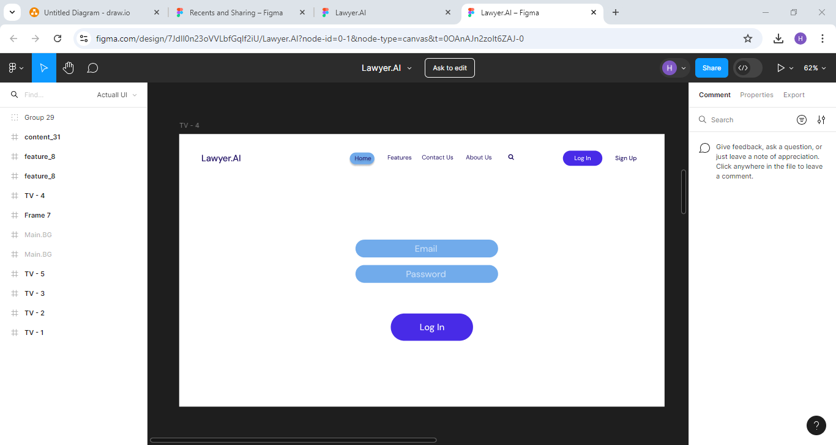

**[Figure: Login page]**

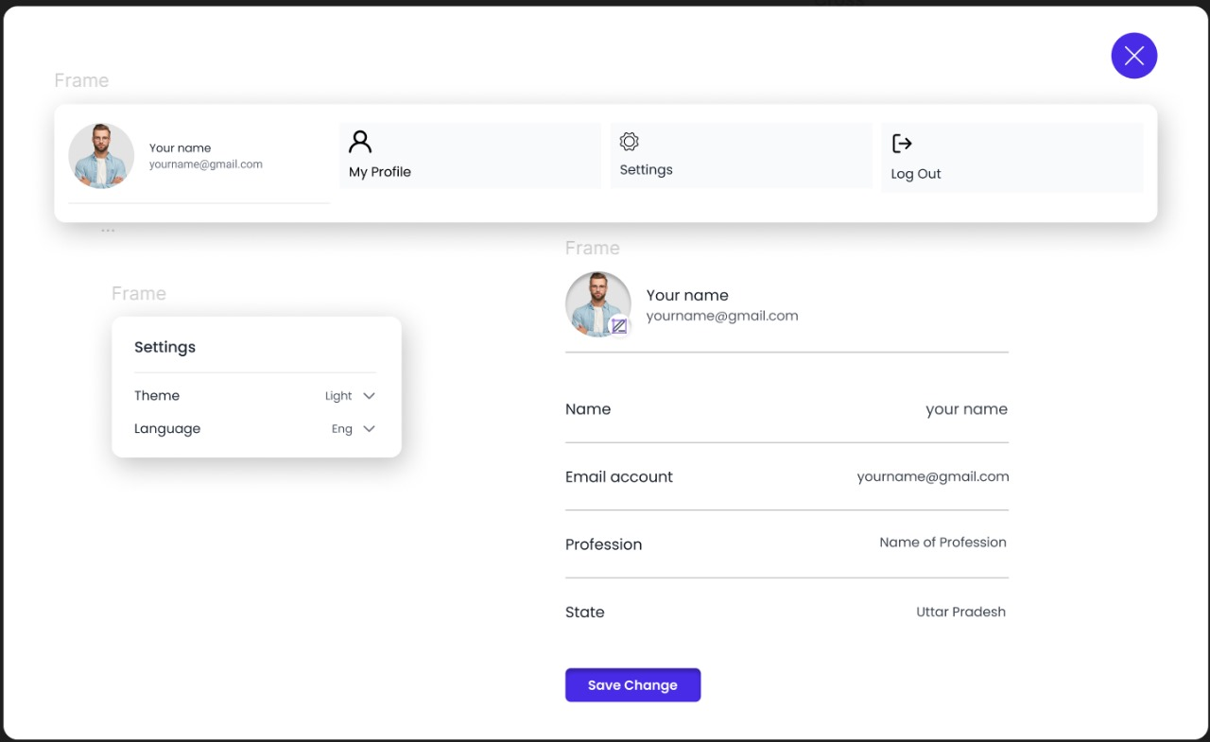

**[Figure: Profile Page]**

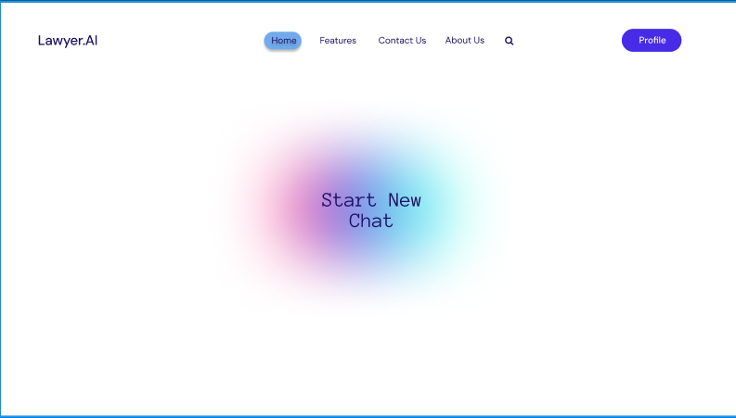

**[Figure: Home Page]**

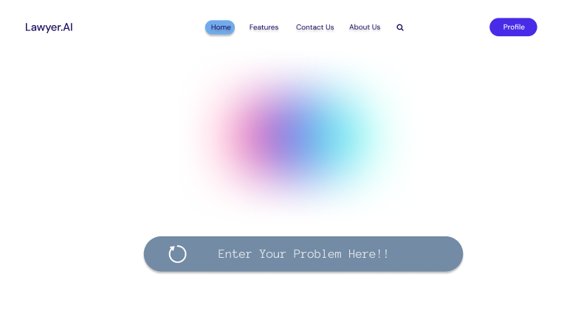

**[Figure: Prompt Page]**

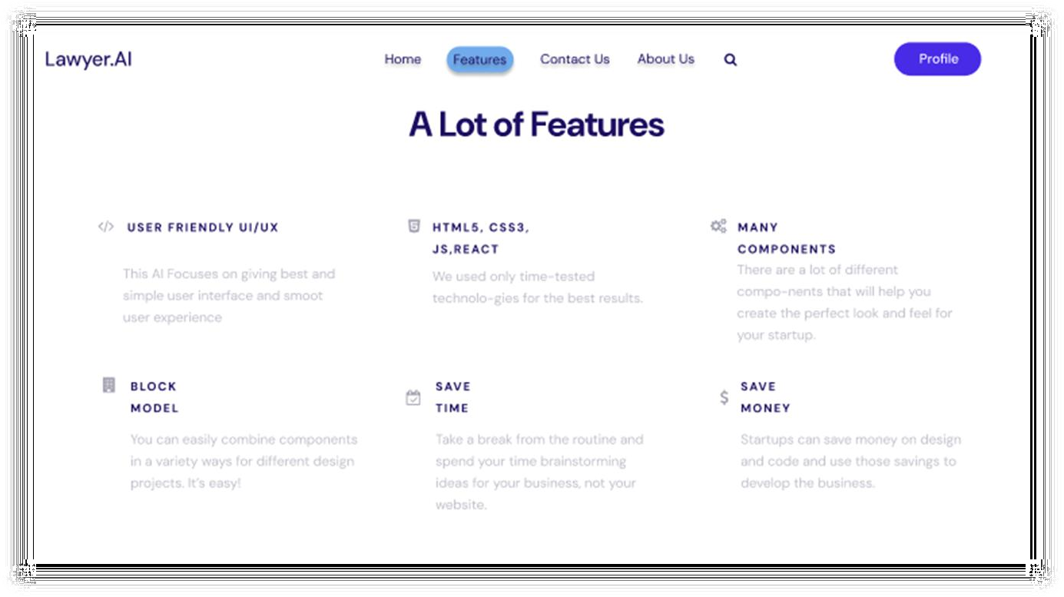

**[Figure: Features Page]**

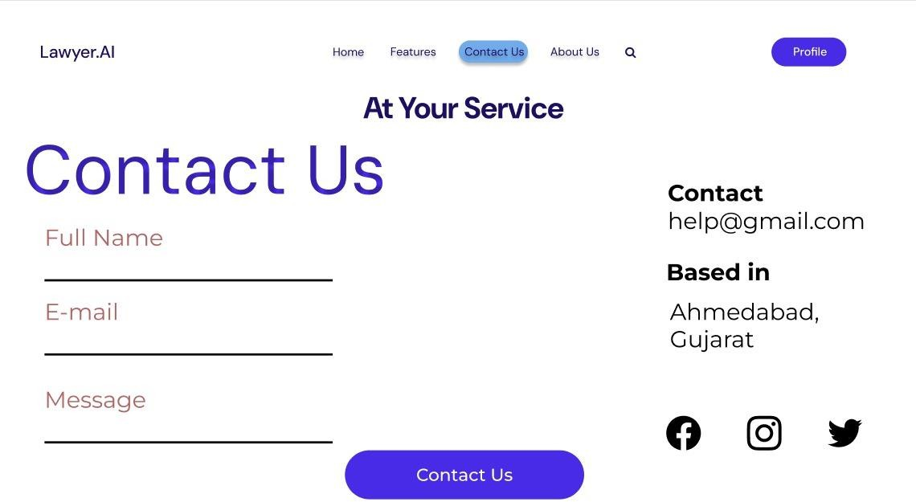

**[Figure: Contact Us Page]**

# CONCLUSION

Lawyer.AI documentation has successfully demonstrated the potential of AI- powered tools in revolutionizing the legal profession. By harnessing the capabilities of lawyers and law students they can streamline their workflow, improve efficiency, and enhance the quality of their legal writing. The documentation has provided a comprehensive guide on how Lawyer.AI is also for civilians for various legal tasks, including summarizing defined text, brainstorming cases, new laws & drafting documents. The Lawyer.AI documentation has shown that AI-powered can be a game-changer for lawyers, and it is up to them to harness its power to improve their practice.

# BIBLIOGRAPHY

### BOOK REFERENCE

1. Aritificial Intelligence and Legal and Legal Analytics Author: Kevin D Ashley
2. Natural Language Processing with Python by O’REILLY Authors:

Steven Bird, [Ewan Klein](https://www.oreilly.com/search?q=author%3A%22Ewan%20Klein%22), [Edward Loper](https://www.oreilly.com/search?q=author%3A%22Edward%20Loper%22)

1. AI For Lawyers Published by: Wiley Author : [Noah Waisberg,](https://www.wiley.com/en-us/search?filters%5bauthor%5d=Noah%20Waisberg&pq=%2B%2B) [Alexander](https://www.wiley.com/en-us/search?filters%5bauthor%5d=Alexander%20Hudek&pq=%2B%2B) [Hudek](https://www.wiley.com/en-us/search?filters%5bauthor%5d=Alexander%20Hudek&pq=%2B%2B)

### WEB REFFERENCE

1. Figma

Link:*https://*[*www.figma.com/proto/7JdIl0n23oVVLbfGqlf2iU/Lawyer.AI?p*](http://www.figma.com/proto/7JdIl0n23oVVLbfGqlf2iU/Lawyer.AI?page-)[*age-*](http://www.figma.com/proto/7JdIl0n23oVVLbfGqlf2iU/Lawyer.AI?page-)*id=0%3A1&node-id=22-90&node- type=canvas&viewport=514%2C380%2C0.48&t=hxQwvzhuAp5f2Gd9- 1&scaling=min-zoom&content-scaling=fixed*

1. Medium

Link: *https://learningdaily.dev/what-is-web-scraping-and-how-we-can- use-it-71e50135a8a2*

1. Medium

Link: *https://medium.com/bb-tutorials-and-thoughts/mastering-nlp-a- comprehensive- guide-for-developers-b5788d7dc00e*

1. Medium

Link: [*https://medium.com/@dhillemann/ai-in-law-7-myths-you-thought-were-*](https://medium.com/%40dhillemann/ai-in-law-7-myths-you-thought-were-true-)[*true-*](https://medium.com/%40dhillemann/ai-in-law-7-myths-you-thought-were-true-) *efb0e357ca33*